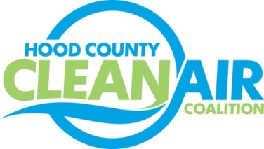
Meeting: Tuesday, March 4, 2014
American Town Hall
220 N. Travis Street, Granbury, Texas 76048
10:00-11:00 a.m.

Agenda

- Call Meeting to Order
- Updates - Michelle McKenzie
  - Natural Gas Workshop Review
  - Ozone Advance
    - Conference Call
    - Annual Update
    - Request for Information
      - Energy Conservation Projects Completed
      - New Ideas for Update
        - Ozone Season Outdoor Burn Ban on Ozone Action Days
        - Employee Notification on Ozone Action Days
  - Review of Hood County 2013 Ozone Season
  - Rider 8
    - PGA Status
    - Project Review
- Regional Updates
  - Solar Meeting
  - Texas AltCar
  - Air Quality Technical Meeting
  - April is National Car Care Month
  - Texas Natural Gas Vehicle Grant Program (part of TCEQ’s TERP)
  - Possible Air Quality Summit to be hosted by TxDOT and TTI
- Discussion
- Adjourn

